# Basic Multithreading

We run the program as ./Sieve-MT-Basic N thread_count

N=20, Thread Count = 2

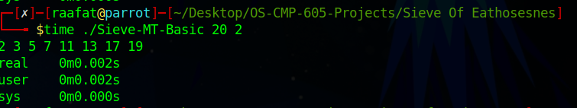

N=20, Thread Count = 4

N=20, Thread Count = 8

N=20, Thread Count = 16

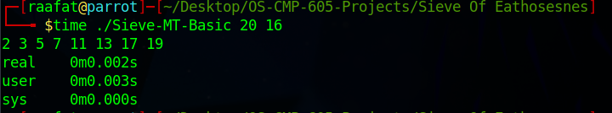

N=200, Thread Count = 2

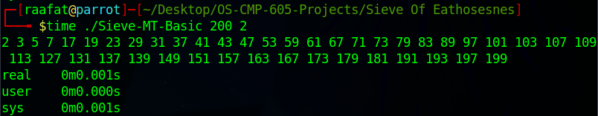

N=200, Thread Count = 4

N=200, Thread Count = 8

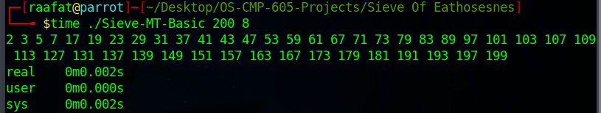

N=200, Thread Count = 16

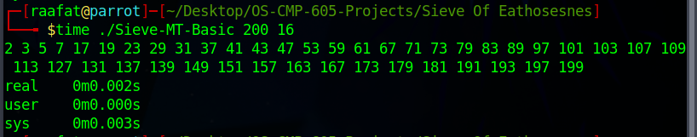

N=2000, Thread Count = 2

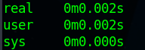

N=2000, Thread Count = 4

N=2000, Thread Count = 8

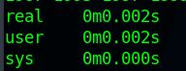

N=2000, Thread Count = 16

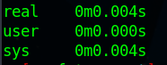

N=20000, Thread Count = 2

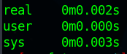

N=20000, Thread Count = 4

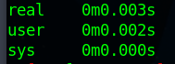

N=20000, Thread Count = 8

N=20000, Thread Count = 16

## Discussion

In Basic Multithreading, we get an increased overhead of thread initialization and context switching when number of threads is big (8,16) and the numbers are small (20,200)

# Advanced Multithreading

We run the program as ./Sieve-MT-Advanced N thread_count

N=20, Thread Count = 2

N=20, Thread Count = 4

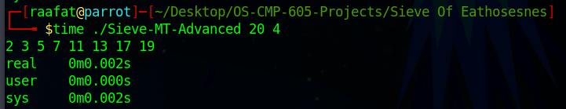

N=20, Thread Count = 8

N=20, Thread Count = 16

N=200, Thread Count = 2

N=200, Thread Count = 4

N=200, Thread Count = 8

N=200, Thread Count = 16

N=2000, Thread Count = 2

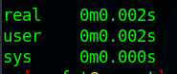

N=2000, Thread Count = 4

N=2000, Thread Count = 8

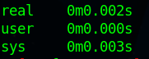

N=2000, Thread Count = 16

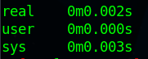

N=20000, Thread Count = 2

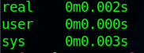

N=20000, Thread Count = 4

N=20000, Thread Count = 8

N=20000, Thread Count = 16

## Discussion

In Advanced Multithreading almost all test cases have the same conclusion. From 4 threads onwards it doesn’t make any appreciable difference. Most of the time is spent by the system handling the threads.

# Multiprogramming

We run the program as ./Sieve-MP N thread_count

N=20, Thread Count = 2

N=20, Thread Count = 4

N=20, Thread Count = 8

N=20, Thread Count = 16

N=200, Thread Count = 2

N=200, Thread Count = 4

N=200, Thread Count = 8

N=200, Thread Count = 16

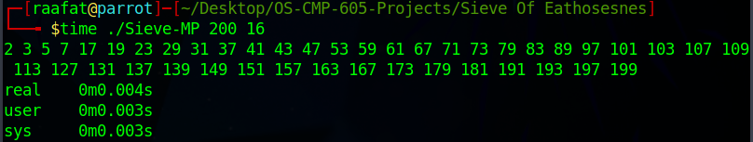

N=2000, Thread Count = 2

N=2000, Thread Count = 4

N=2000, Thread Count = 8

N=2000, Thread Count = 16

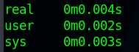

N=20000, Thread Count = 2

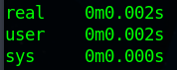

N=20000, Thread Count = 4

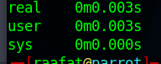

N=20000, Thread Count = 8

N=20000, Thread Count = 16

## Discussion

In Multiprogramming due to the heavy nature of forking processes. In all but the test case of 20000 showed slower performance due to the management of forked processes in cases of 8, and 16 processes and 4 processes when dealing with low numbers like 20.